**How To Get UDID Of Your Device**

1. UDID (Unique Device Identifier) is a 40-digit character code *allotted to Apple devices viz. iPhone, iPad, iPod* etc. for “*Identification*” purpose. It is a compilation of letters and numbers and is used by developers to register the devices for testing their apps.

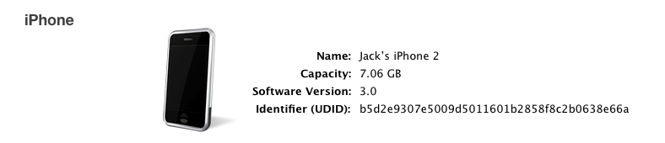

**Ways to Getting UDID from the iTunes**

* Plug in your device to the computer using USB cable and launch *iTunes*.

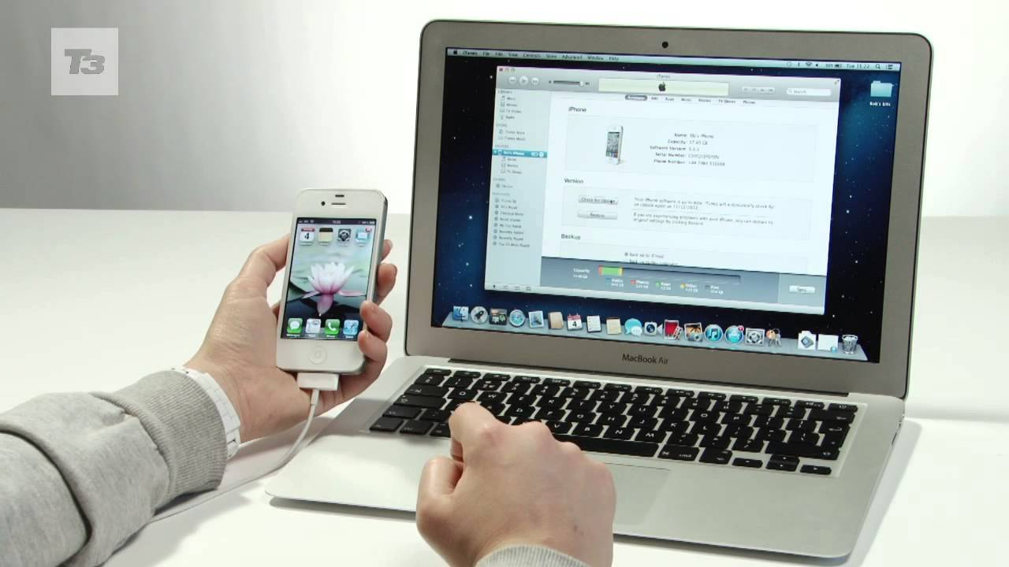

* From the Navigation Menu displayed at the top left, select “*iPhone or iPad”* under Device option.
* Select *Summary* section.

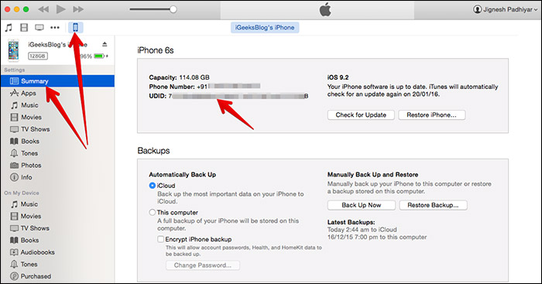

* Make sure you are on the Summary Page and here, click on the “*Serial Number*” and it will get *changed to “UDID Number”* of your device.

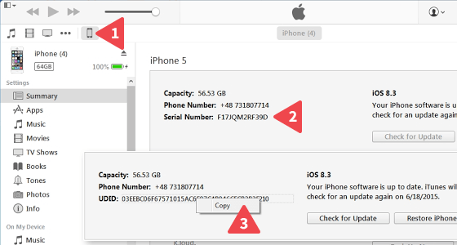

* You can now Copy the UDID number by pressing *Ctrl+C* or *Command+C* and can paste it anywhere either on Microsoft Word, clipboard or anywhere else.

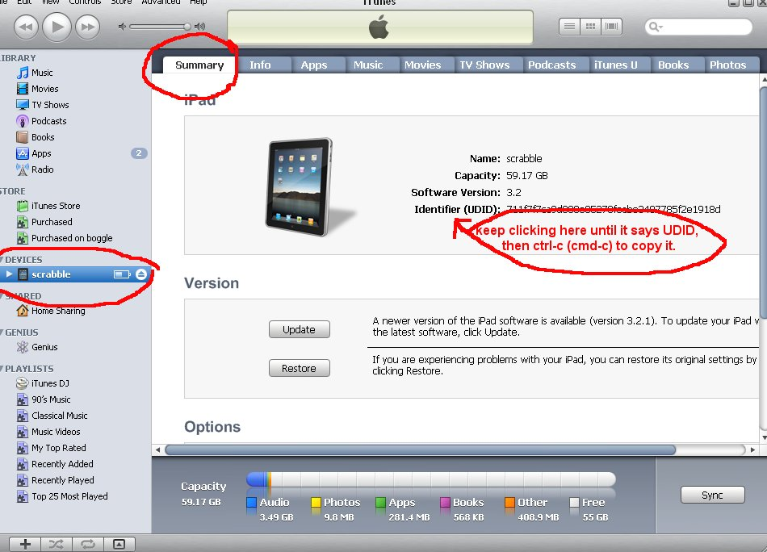

**How to obtain UDID without iTunes?**

* Go to the *Safari* on your Apple device.
* Open the site get.udid.io.

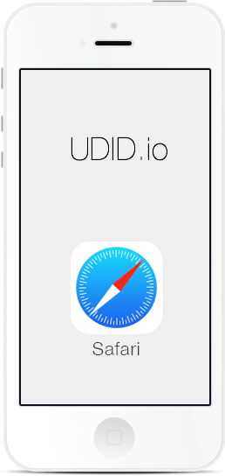

* Then click on “*Tap to get UDID*” option.

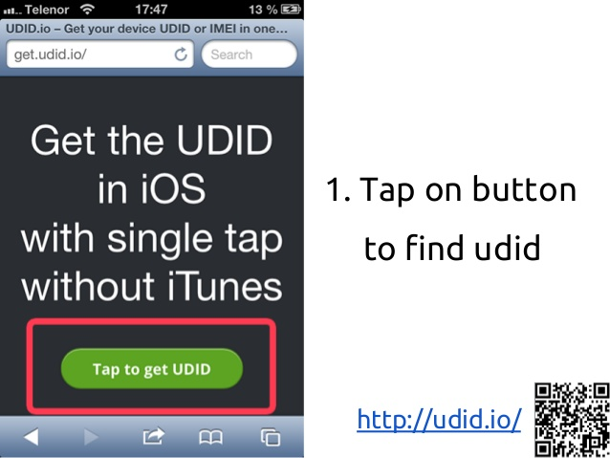

* It will automatically lead you to the *Settings* *Page*.
* Select the General option and thus, a dialogue box will appear.
* Accept installation of the OTA certificate by clicking on Install and then enter your password.
* After entering your password just click on “*Install”* Profile.

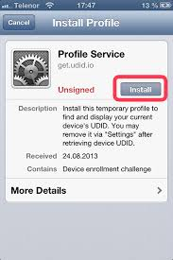

* Then an another screen will be loaded in Safari which will be displaying the *UDID, IMEI,* and *Serial Number* of your iPhone/iPad.

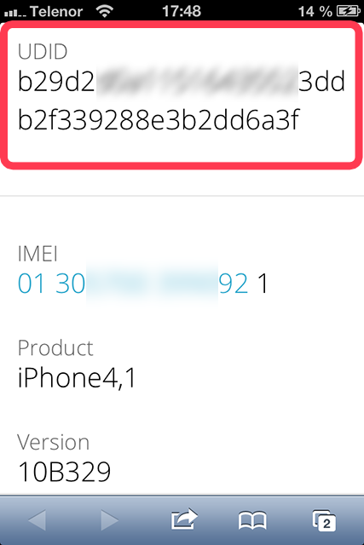

**Method to find UDID from Apple iPhone/iPad if Cloud is locked**

* Connect your device to the PC.
* Click on the *Start Button* in the bottom left corner of computer’s screen.
* A dialogue box will appear, select the *Control Panel* option.

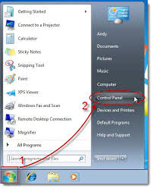

* Under the *Hardware and Sound* settings, click on *View devices and printers* option.
* 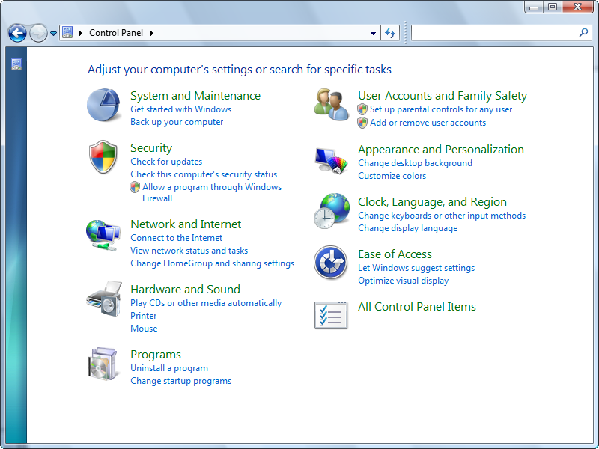Double click on “*Apple Mobile Device USB Driver*” and it will show you the properties of your device.
* Click on Hardware option, select your device and then click on the “*Properties*” button.
* A screen will appear where you need to select the Details option. When you click the "*Details*" tab, a drop-down menu will appear where you have to select "*Device Instance Path*".

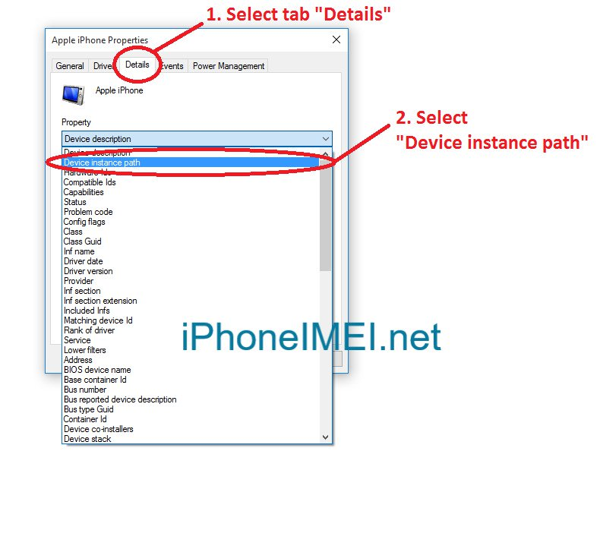

* The 40 characters codes after “\” at the last, under "*Value*" is your device's UDID number.

